2021 ADOPTED
BUDGET
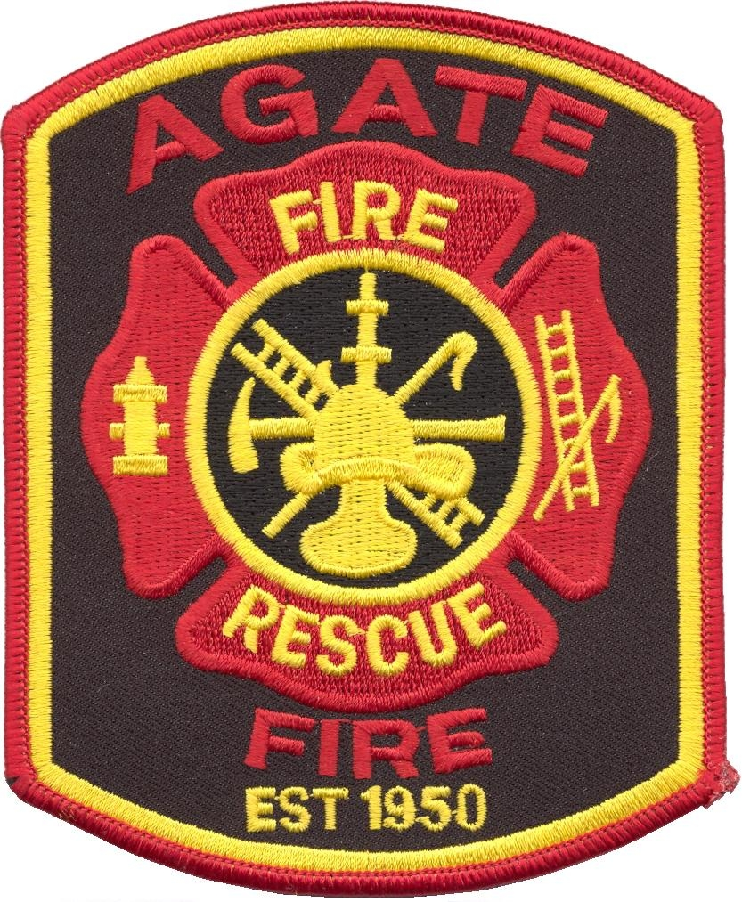

Adopted by the Agate Fire Protection District Board of Directors on December 10, 2020
(Via ZOOM Video Call)

AGATE FIRE PROTECTION DISTRICT
2021 Budget

FUNCTIONAL DESCRIPTION/WORK OBJECTIVES
The Fire Department has five basic functional responsibilities:
Fire Suppression: includes residential, agricultural, oil and natural gas pump and storage sites, automobile, farm equipment, and wildland fires. The Agate Fire Protection District (AFPD) provides fast attack firefighting in order to minimize risk to life, property and the environment.
Emergency Medical Services: are provided twenty-four hours a day by a skilled life support team of paramedics and EMTs. AFPD operates two fully equipped ambulances.
Fire Prevention: is responsible for hazard abatement enforcement, approval of building plans, public education, environmental protection and fire safety inspections.
Training: of Fire Department personnel is conducted in accordance with county, state and federal standards. Firefighters, EMTs, and paramedics receive updates on advances in techniques and technology, and participate in continuing education.
Community Emergency Preparedness: includes training programs offered to organizations and individuals within the District. This includes a yearly educational event held at the Agate School.
BUDGET MESSAGE
The 2021 AFPD budget has been prepared in compliance with Colorado Revised Statutes and Special District budget laws. Consideration has been given to all functions and operations of the AFPD. The intent of this budget is to provide quality service to the District while operating within the restraints of limited revenues.
The attached budget is based on the priorities expressed by the Fire/Rescue and the EMS/Ambulance departments. The proposed budget for the 2021 Fiscal year for the AFPD maintains the level of services provided last fiscal year.
The process for developing the budget was as follows: The Board of Directors all served as members of the Budget Committee. These members included Fire Chief Larry Rector, Assistant Fire Chief Jerrel Rector, President Kent Dyson, Vice President Casey Craven, Secretary/Treasurer Lloyd Wallace, Directors Joe Craven, and Roy Obrigewitch. Using preliminary information from the County as a basis of tax levy revenues, 15% was set aside for the Reserve Fund. The committee then tracked the actual expenditures from the 2020 budget to determine any line items that were over or under budget. Reasons for why a line item would be over budget were analyzed to assure the 2021 budget would accurately reflect any corrections needed. Based on input from Chief Rector on anticipated needs for the Fire/Rescue and EMS/Ambulance departments, expenditures were prioritized. Those expenditures that met the criteria for needed expense were added to the budget. Finally the budget was formulated and confirmed to be in balance.
The AFPD must remain fiscally conservative to assure a healthy fund balance and to provide for the future. The assessed valuation of the county for 2021 has increased slightly over 2020. The mill levy will remain the same for 2021 at 8 mills. With an assessed property value at $12,376,138.00 the budgeted property tax revenue will be at $99,091.00. This is an increase of 1.09% over 2020.
Again this year it is estimated that the AFPD will end the current year under budget as the Board continues to make responsible fiscal decisions. The estimated carry over into the 2021 budget is $129,536.00.
Total Budgeted Income for 2021 is: $183,919.00
Total Budgeted Expenses for 2021 are: $135,917.00
Leaving a total Reserve at the end of 2021: $4,077.00

Respectfully submitted to the AFPD Board of Directors by the Budget Committee on December 10, 2020.

GENERAL FUND BUDGET
AGATE FIRE PROTECTION DISTRICT
 | JANUARY 1 - DECEMBER 31, 2021
 | DESCRIPTION | ACTUAL PRIOR YEAR 2019 | ESTIMATED CURRENT YEAR 2020 | BUDGET YEAR 2021
Beginning Balance January 1 |  | $ 76,394.48 | $ 154,350.23 | $ 129,536.95
REVENUE
 | Metro Grow | $ 5,618.00 | $ 4,798.00 | $ 5,000.00
 | Donations |  | $ 2,450.00 | $ 2,500.00
 | Capital Credits |  |  | $ 70.00
 | Property Tax - Senior/Vet Exempt | $ 509.42 | $ 651.97 | $ 500.00
 | Property Tax - Current Tax | $ 83,702.00 | $ 88,711.80 | $ 99,091.00
 | Property Tax - Specific Ownership Tax | $ 13,869.45 | $ 12,766.49 | $ 12,000.00
 | Property Tax - Current Interest | $ 45.82 | $ 104.93 | $ 60.00
 | State Grant Revenue |  | $ - | $ -
 | Fire/Rescue Grants (matching) |  | $ - | $ -
 | Fire - WIBS Collections |  | $ 30.50 | $ 300.00
 | Fire/Rescue Grants (non-matching) |  | $ - | $ -
 | EMS Grants (matching) | $ 28,351.76 | $ - | $ 29,398.00
 | EMS Grants (non-matching) |  | $ - | $ -
 | EMS Equipment Sales |  | $ - | $ -
 | EMS WIBS Collection | $ 26,522.00 | $ 36,558.00 | $ 35,000.00
TOTAL REVENUE |  | $ 158,618.45 | $ 146,071.69 | $ 183,919.00
TOTAL AVAILABLE FUNDS |  | $ 235,012.93 | $ 300,421.92 | $ 313,455.95
 | DESCRIPTION | ACTUAL PRIOR YEAR 2019 | ESTIMATED CURRENT YEAR 2020 | BUDGET YEAR 2021
EXPENDITURES
 | Fire - Fire Prevention Education |  | $ - | $ 100.00
 | Fire - Fire Equipment | $ 18,274.00 | $ 19,773.00 | $ 11,000.00
 | Fire - Wild Land Grant |  | $ - | -
 | Fire - Matching Grants |  | $ - | -
 | Fire - ECCA | $ 600.00 | $ 600.00 | $ 700.00
 | Fire - Certification/Training |  | $ - | $ 1,000.00
 | Fire - Membership Fees | $ 240.00 | $ 625.00 | $ 500.00
 | Fire - WIBS Billing |  | $ - | $ 250.00
 | Fire - Truck Lease | $ 200.00 | $ 200.00 | $ 200.00
 | Fire - Radio Use Fee |  | $ - | $ 100.00
 | Fire - Miscellaneous |  |  | $ 100.00
 | Fire - PPE |  | $ 107.00 | $ 2,000.00
 | Fire - Purchased Services | $ 900.00 | $ 15.00 | $ 200.00
 | Fire - Apparatus Maintenance/Repair | $ 779.00 | $ 10,382.00 | $ 10,000.00
 | Fire - Equipment Maintenance | $ 378.00 | $ 7,630.00 | $ 1,000.00
 | Fire - Pump Testing | $ 800.00 | $ 763.27 | $ 800.00
 | EMS - Ambulance Maintenance/Repair | $ 1,522.00 | $ 10.00 | $ 2,000.00
 | EMS - Purchased Services |  | $ 248.00 | $ 500.00
 | EMS - Rent, Parking, Utilities |  | $ - | -
 | EMS - Ambulance Inspections | $ 250.00 | $ 500.00 | $ 500.00
 | EMS - License Plates |  | $ - | $ -
 | EMS - Ambulance Grant |  | $ - | $ -
 | EMS - Grant Match |  |  | $ -
 | EMS - Equipment |  | $ 29,398.00 | $ 2,500.00
 | EMS - Equipment Maintenance/Repair | $ 826.00 | $ 250.00 | $ 1,000.00
 | EMS - Medications | $ 4,526.00 | $ 1,462.00 | $ 2,500.00
 | EMS - Disposable Supplies | $ 121.00 | $ 14,873.00 | $ 4,000.00
 | EMS - Training | $ 703.00 | $ - | $ 1,200.00
 | EMS - Insurance |  | $ 1,000.00 | $ 1,000.00
 | EMS - WIBS Billing | $ 6,772.00 | $ 11,095.00 | $ 12,000.00
 | EMS - Tolls/Parking |  | $ 37.50 | $ 50.00
 | EMS - Miscellaneous | $ 200.00 | $ - | $ 100.00
 | Building - Expenses | $ - | $ - | $ 200.00
 | General - Bookkeeper Salary | $ 2,400.00 | $ 2,400.00 | $ 2,400.00
 | General - Insurance P&L | $ 10,733.00 | $ 12,200.00 | $ 10,000.00
 | General - Bond Insurance | $ 350.00 | $ 350.00 | $ 350.00
 | General - Work Comp Insurance | $ 1,214.00 | $ 1,686.00 | $ 2,000.00
 | General - Legal Expense | $ - | $ 8,000.00 | $ 15,000.00
 | General - Station Maintenace/Repair | $ 4,915.00 | $ 25,084.00 | $ 1,000.00
 | General - Purchased Services |  | $ - | $ 150.00
 | General - Subscriptions |  | $ - | $ 200.00
 | Office - Postage | $ 142.50 | $ 55.00 | $ 100.00
 | Office - Supplies | $ 20.00 | $ 60.00 | $ 150.00
 | Office - Website |  | $ - | $ 75.00
 | Office - Advertisement - Legal Notice |  | $ - | $ 200.00
 | Office - Election Expenses |  | $ - | $ -
 | Office - Audit Expenses | $ 300.00 | $ 325.00 | $ 350.00
 | Technology - Radios/Tower | $ 7,470.00 | $ 5,485.00 | $ 3,000.00
 | Treasurer's Fee (3.1%) | $ 2,271.00 | $ 2,700.00 | $ 2,800.00
 | FICA Withholding | $ 367.20 | $ 367.20 | $ 400.00
 | Stipend Payments |  | $ - | $ 100.00
 | 15% Reserve |  | $ - | $ 27,587.85
 | Utilites - Propane | $ 2,260.00 | $ 2,551.00 | $ 3,000.00
 | Utilities - Electricity | $ 1,811.00 | $ 3,247.00 | $ 3,000.00
 | Utilities - Phone/DSL | $ 532.00 | $ 550.00 | $ 550.00
 | Utilities - Water | $ 936.00 | $ 1,011.00 | $ 1,500.00
 | Utilities - Trash Removal | $ 552.00 | $ 552.00 | $ 555.00
 | Combined - Bulk Fuel | $ 3,898.00 | $ 3,318.00 | $ 3,700.00
 | Combined - Fuel | $ 75.00 | $ 60.00 | $ 100.00
 | Combined - Household | $ 1,645.00 | $ - | $ 150.00
 | Combined - Meals/Water | $ 1,680.00 | $ 1,915.00 | $ 2,000.00
TOTAL EXPENDITURES |  | $ 80,662.70 | $ 170,884.97 | $ 135,917.85
 | Annual Net | $ 77,955.75 | $ (24,813.28) | $ 48,001.15
Ending Balance December 31  (Beginning Bal. + Annual Net) |  | $ 154,350.23 | $ 129,536.95 | $ 177,538.10
 | Emergency Reserve (3% Reserve of annual expendtures DO NOT SPEND) | $ 2,419.88 | $ 5,126.55 | $ 4,077.54
 | Unrestricted Reserves(Ending balance-Emergency Reserve) | $ 151,930.35 | $ 124,410.40 | $ 173,460.56

